1. 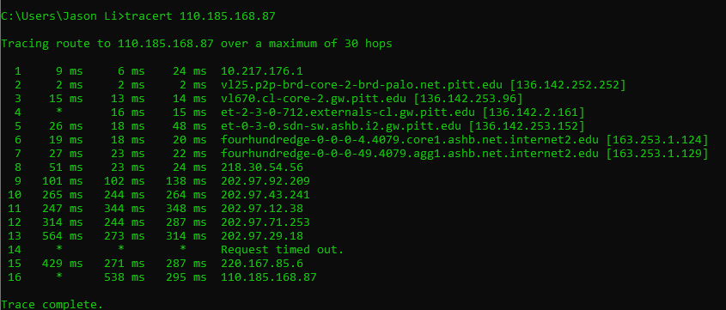
2. Interesting points about date center.
3. There are **over 7,500** data centers worldwide.
4. The Natural Resources Defense Council (NRDC) estimates that data centers consume up to 3% of all global electricity production.
5. **California** has the largest concentration of data centers in the U.S. with just over 300 locations.
6. The largest data center in the world (Langfang, China) is **6.3 million square feet.**
7. The average data center consumes **over 100x** the power of a large commercial office building.

Source:

Corporation, C. (2020). *12 mind-blowing data center facts you need to know*. Ciena. Retrieved September 6, 2022, from https://www.ciena.com/insights/articles/Twelve-Mind-blowing-Data-Center-Facts-You-Need-to-Know.html